INTRODUTION
OVERVIEW
- To create a business card our institution
- Purpose
To reach the students with tha business card

PROBLEM DEFINITION & DESIGN THINKING
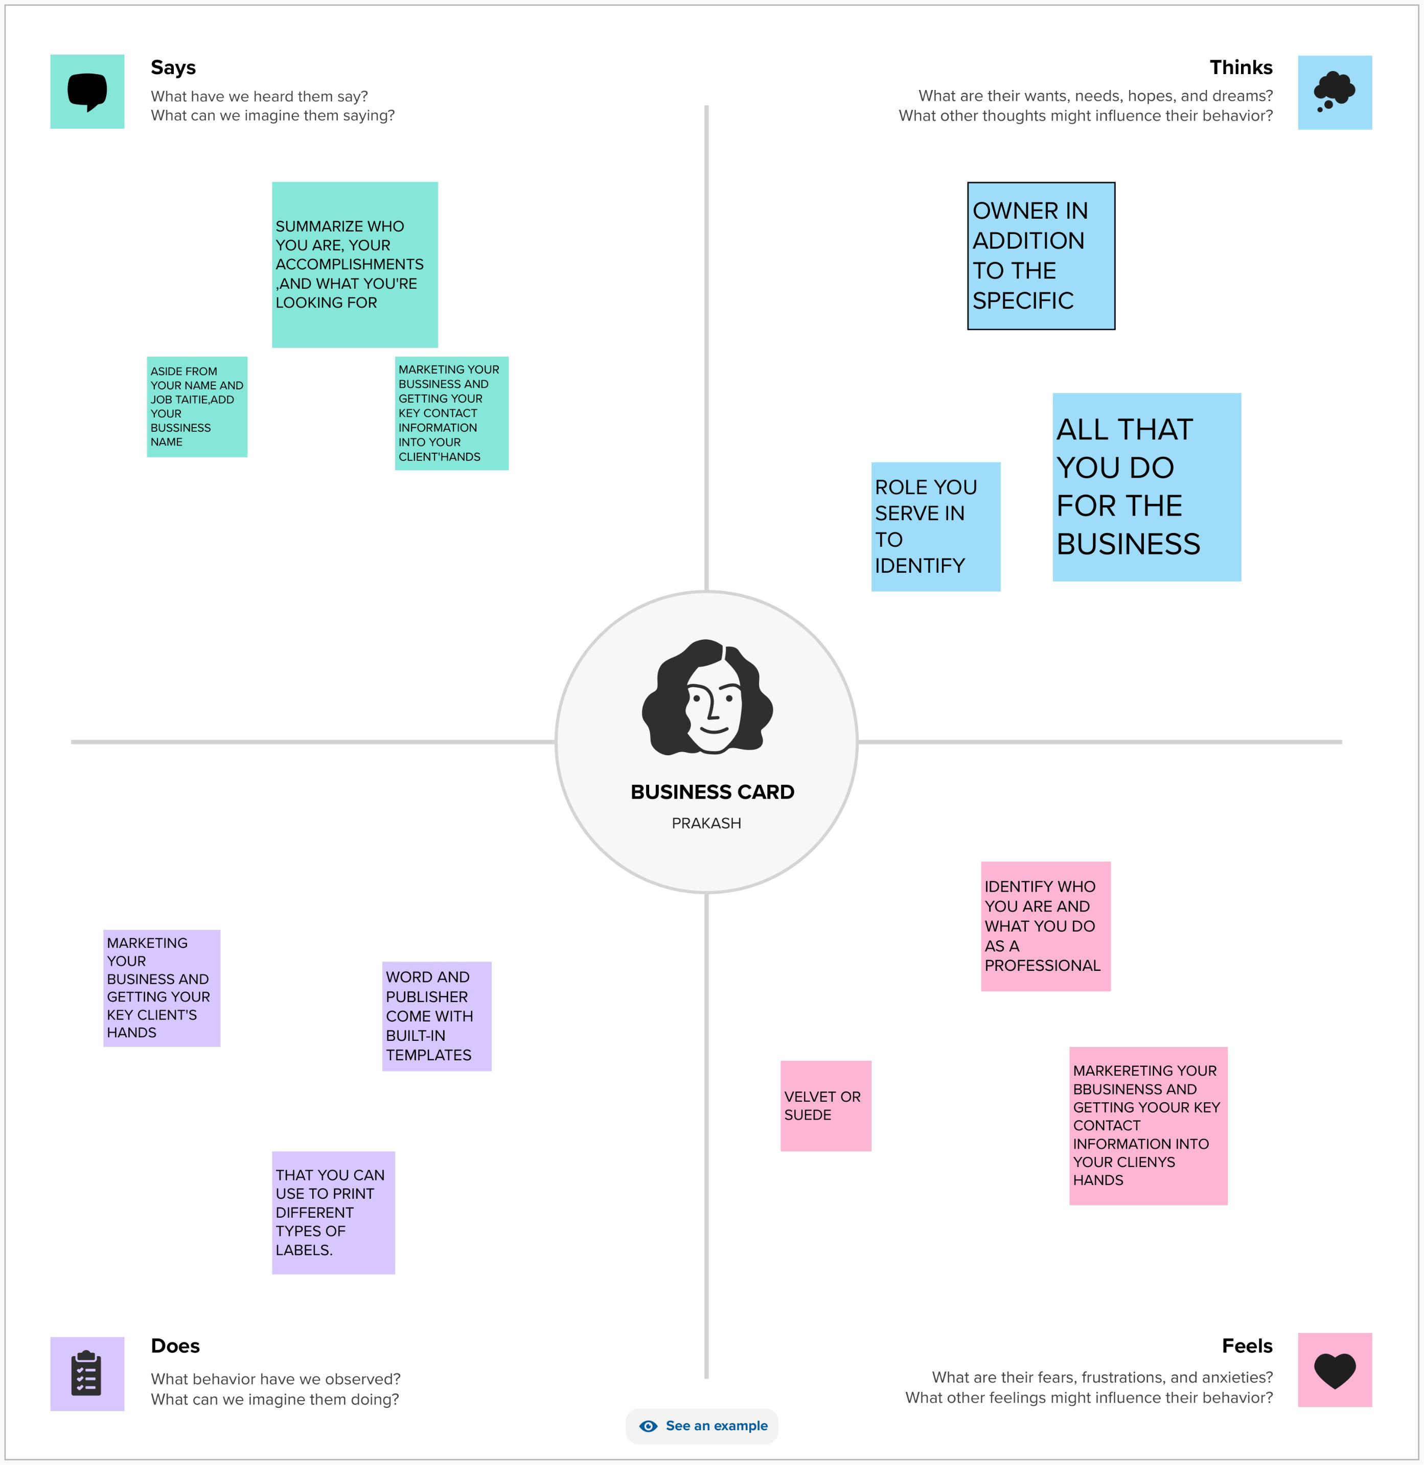
EMPATHY MAP:

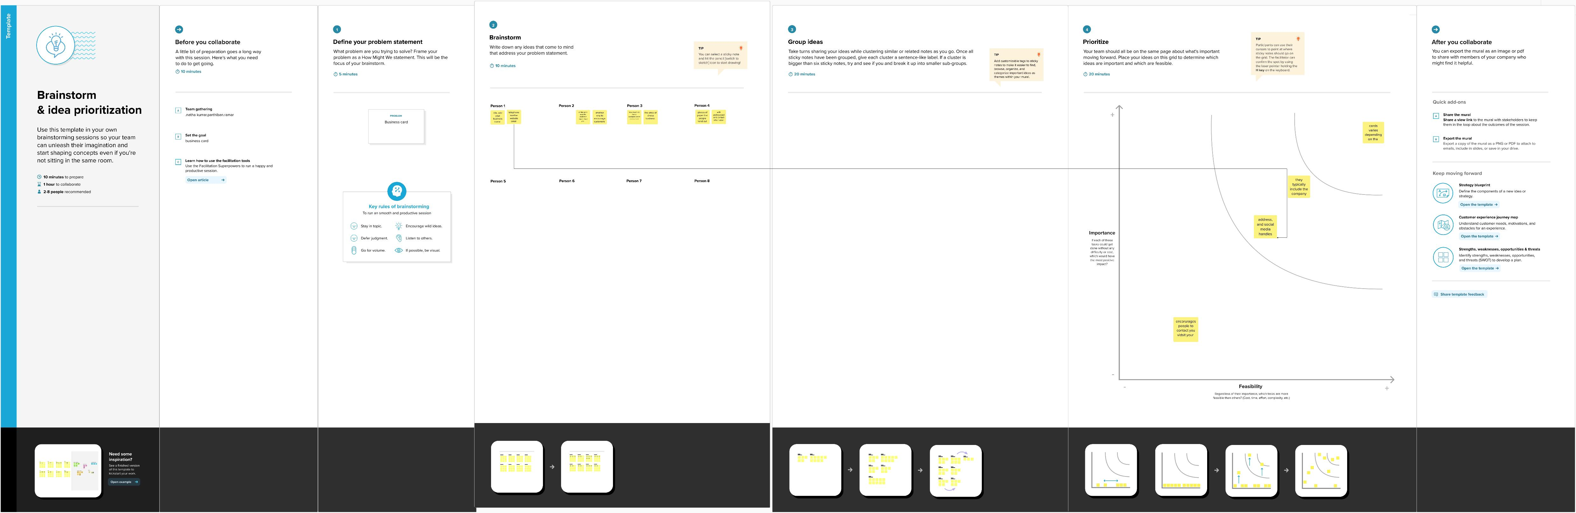
BRAIN STROM :

RESULT

ADVANTAGES & DISADVANTAGE

- It's easy to reach tha people at any time
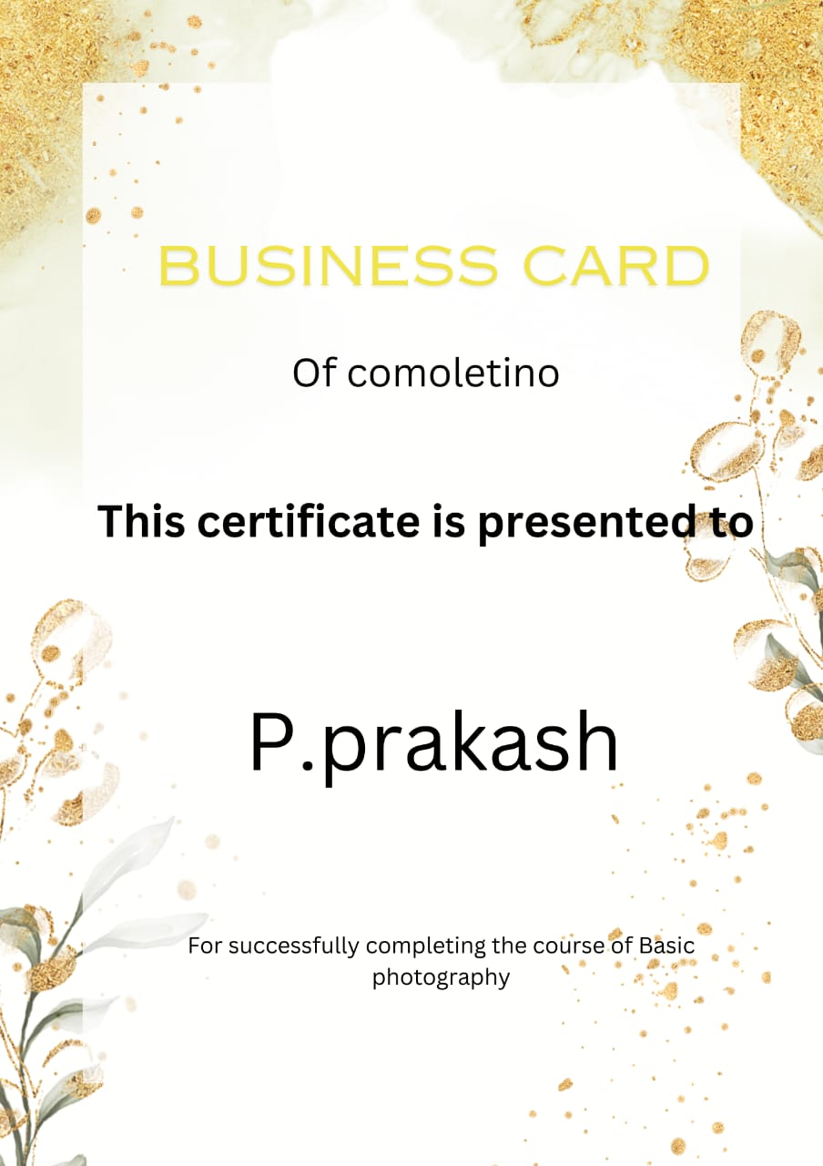
APPLICATION:
It can gather all people

CONCLUSION:
Successfully created business card using tha canva app

